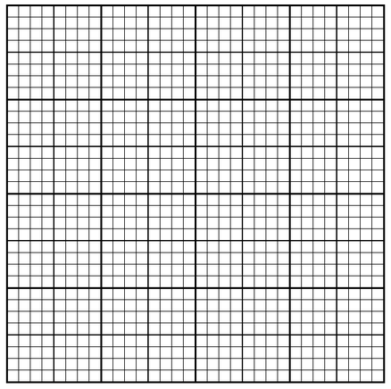
Graphing Mechanical Advantage versus Effort Arm
Effort Arm (centimeters)
But on the left and right axis, each line is equal to 0.2!
Beware!
On the up and down axis, each line is equal to 0.01!
12
11
10
9
8
7
6
5
4
0.0
0.05
0.1
0.15
0.2
0.25
0.3
0.35
0.4
Mechanical Advantage

